TOTHBOT — KRAKEN SYSTEM ARCHITECTURE OVERVIEW
The Complete System — All Architectural Decisions + All Flow Diagrams
DocDCN: 0500000
DocTitle: TothBot_Kraken_System_Architecture_Overview
DocVersion: dv1_13
DocOwner: Bill
DocPath: GitHub.com/TothBot/TothBot-V2-Docs/05XXXXX_System_Architecture/0500000_System_Architecture_Overview_dv1_13.docx
DocDate: 03-26-2026
DocTime: 23:59:59 UTC

PURPOSE: This document captures all architectural decisions, FP/DP analyses, and system specifications from the TothBot Kraken architecture sessions of March 2026. Includes all six system flow diagrams showing connections between Kraken, TothBot, and CIATS as one unified organism.

Diagrams in this document (dv1_13 — diagrams unchanged from dv1_10)
Diagram 1 — Kraken API Connection Architecture
(dv1_6: amend_order primary, batch_cancel, WS ping A-7, zombie A-8, balances seq A-9, per-pair status, L3 URL corrected)
(dv1_7: executions seq gap detection A-10, GetOpenOrders gap recovery)
(dv1_9: GAP-A order_status:true CRITICAL FIX, GAP-C price_increment, GAP-D qty_min/cost_min, GAP-E max_size=10MB, IMP-11 maxratecount, IMP-13 warnings[])
(dv1_10: GAP-B stp_type underscore CORRECTION, A-21 deadline, IMP-16 aiohttp ClientTimeout, IMP-17 TCPConnector, IMP-18 ticker bbo)
(dv1_13: text-only updates — diagrams unchanged)
Diagram 2 — TothBot Trading Pipeline (dv1_6: per-pair instrument status check added before Gate 1)
Diagram 3 — Exit Architecture: Ground Zero Redesign (dv1_6: title updated)
Diagram 4 — Regime Taxonomy: 6-Regime Grid + Two-Level Tagging (dv1_6: title updated)
Diagram 5 — CIATS Architecture: Data Flows and Improvement Cycle (dv1_6: title updated)
Diagram 6 — Complete System: One CIATS-Owned Organism
(dv1_9: GAP-A through F, IMP-11 through 17) (dv1_10: GAP-B correction, A-21 deadline, IMP-16/17 aiohttp, IMP-18 bbo, IMP-19 regime stagger)

1. System Identity and Mission

1.1 What TothBot Is
TothBot is an automated cryptocurrency spot trading system on Kraken exchange. It runs 24/7/365 on a Hetzner VPS, processes 5-minute OHLC candle close events as its system clock, and executes long-only trades using a momentum-based signal engine.
TothBot is not an external system connected to Kraken — it IS Kraken's event processor. Every action is a response to a Kraken push event. No timers. No polling. Idle and silent until Kraken speaks.

1.2 The One Organism Principle
Three functional zones, one organism:
Kraken: generates events, executes orders, holds resting TP limit orders and off-book emergency SL stop orders on matching engine
TothBot: processes Kraken events, executes trading strategy, manages positions
CIATS: learns from event records, continuously improves processing rules
PRIMARY MISSION: Maximize profit. Minimize loss. With an emphasis on minimizing loss. Loss prevention takes priority over profit generation. Everything else is secondary.

1.3 Operating Environment
Exchange: Kraken Spot (Long Module — Short deferred)
Language: Python 3.12.3
VPS: Hetzner CPX22 — 87.99.141.44 — Ashburn VA (Kraken Spot servers: AWS us-west-2 Oregon)
★ Evaluate Hillsboro OR [dv1_6 IMP-01 — adjacent to Kraken AWS]
System Clock: Kraken OHLC 5-minute candle close event (WS v2 push)
Fee Baseline: Maker 0.16% / Taker 0.26% (CIATS monitors actuals)
Operation: 24/7/365 — CIATS may add stand-down periods via PDCA if data supports
Starting Portfolio: $1,000 Long Module
Sacred constraint: Net 1:1.5 R:R — HARDCODED — the only number not owned by CIATS

2. Kraken API Connection Architecture
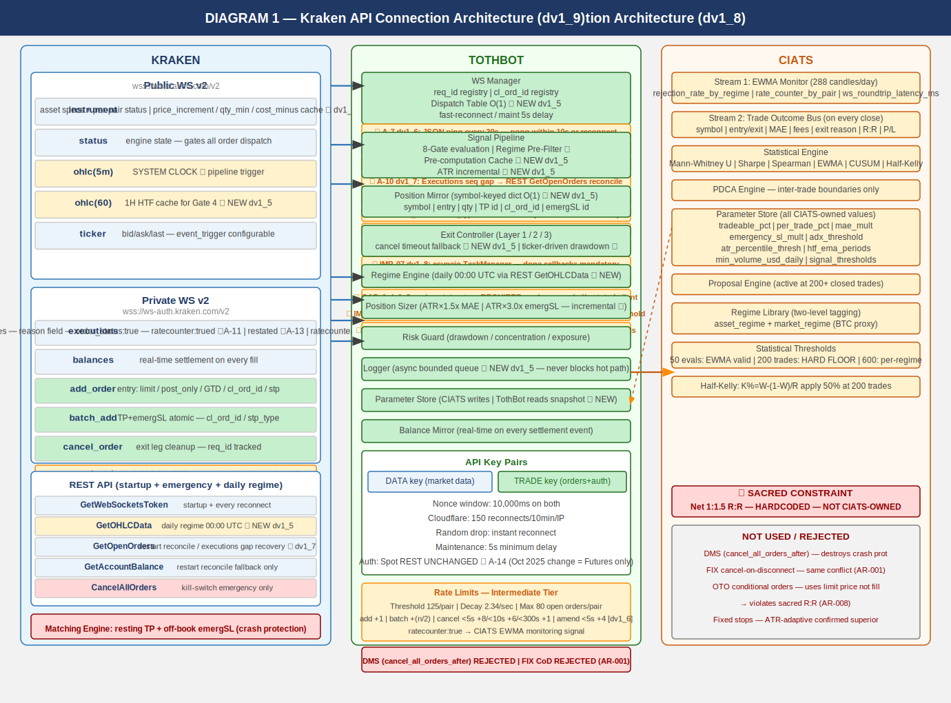
All connection points verified across 3 independent analysis passes (15 sources) plus 2 deep validation sessions (144+ sources total) plus 10-search FP/DP Kraken validation [dv1_6] (126 sources) plus 6 additional 10-search validation sessions (TB00015–TB00017).

2.1 Key Connection Points
PUBLIC WS v2 (wss://ws.kraken.com/v2):
instrument — asset specs + per-pair status cache ★ dv1_6
price_increment / qty_increment / qty_min / cost_min ★ GAP-C/D dv1_9
status — global engine state (online/post_only/cancel_only/maintenance)
ohlc(5m) — SYSTEM CLOCK (pipeline trigger, fires on trade events)
ohlc(60) — 1H HTF cache for Gate 4 ★ NEW dv1_5
ticker — price data, event_trigger:bbo (open positions) or event_trigger:trades (others)

PRIVATE WS v2 INBOUND (wss://ws-auth.kraken.com/v2):
executions — fills/expirations/SL-TP triggers, ratecounter:true (A-1),
snap_orders:true, snap_trades:true, order_status:true on reconnect (A-3),
sequence gap detection ★ A-10 dv1_7
CRITICAL ★ GAP-A dv1_9: order_status:true MANDATORY
balances — real-time settlement, sequence gap detection ★ A-9 dv1_6
MUST use wallets[type=spot][id=main].balance ONLY ★ AR-050 dv1_13

PRIVATE WS v2 OUTBOUND:
add_order — entry: limit/post_only/GTD/cl_ord_id/stp_type:cancel_newest/deadline:now+5s
amend_order — PRIMARY amendment method (edit_order DEPRECATED ★ dv1_6)
batch_add — SL+TP atomic on fill. cl_ord_id/stp_type:cancel_newest/deadline:now+5s
cancel_order — exit leg cleanup, req_id tracked
batch_cancel — Full Halt multi-order cancel ★ dv1_6

REST (startup + emergency + daily regime):
Status API — startup maintenance check (AR-038) — informational, non-blocking
GetWebSocketsToken — startup/every reconnect
GetOHLCData — daily regime 00:00 UTC + startup warm-up ★ AR-044 dv1_13
CRITICAL: exclude response[-1] always ★ dv1_6
STAGGER 1.1s between pairs ★ AR-036
GetOpenOrders — restart reconcile fallback / executions gap recovery ★ dv1_7
GetAccountBalance — restart reconcile fallback / balances gap recovery ★ dv1_6
CancelAllOrders — kill switch emergency only

MATCHING ENGINE:
Resting TP limit orders and off-book emergency SL stop orders survive any TothBot
failure independently — crash protection always active

EVALUATED AND REJECTED:
cancel_all_orders_after (DMS) — destroys crash protection (AR-001, AR-055 dv1_13)
FIX API cancel-on-disconnect — same architectural conflict (AR-001)
OTO conditional orders — uses limit price not fill price, violates R:R (AR-008)

2.2 Four Kraken Engine States
online — All orders. Signal pipeline runs normally.
post_only — TothBot limit+post_only entries ARE valid. Trading continues.
cancel_only — No new entries. Exit Controller can cancel. Resting orders active.
maintenance — No orders, no cancels. Resting TP and emergSL active on engine.

2.3 API Rate Limits — Intermediate Tier (C-2)
Rate limits shared across REST, WebSockets, and FIX — no separate per-protocol budget.

Rate counter threshold (per pair): 125 (use maxratecount from executions ACK ★ AR-030)
Rate counter decay (per second): 2.34
Max open orders (per pair): 80
Add order fixed cost: +1
Amend order cost ★ dv1_6 (PRIMARY): +1 fixed, +3(<5s), +2(<10s), +1(<15s)
Edit order (DEPRECATED ★ dv1_6): +1 fixed, +6(<5s), +5(<10s) — DO NOT USE
Batch add fixed cost: +(n/2)
Cancel order cost (< 5s old): +8
Cancel order cost (< 10s old): +6
Cancel order cost (< 300s old): +1
Batch cancel cost ★ dv1_6: Cumulative sum. Bypasses rate counter ceiling.

amend_order is 43% cheaper than edit_order for orders resting <5s (+4 vs +7).
amend_order preserves queue position (unlike cancel+resubmit).

2.4 WS Operational Requirements (A-1 through A-24)
A-1 Rate counter monitoring via executions channel. ratecounter:true subscription. CIATS EWMA Monitor adds rate_counter_by_pair.
A-2 req_id and cl_ord_id on all outbound WS messages. cl_ord_id assigned at dispatch — Position Mirror records immediately, no async gap.
A-3 Round-trip latency monitoring. time_in/time_out on all WS v2 responses. CIATS EWMA Monitor adds ws_roundtrip_latency_ms.
A-4 stp_type:cancel_newest on all WS v2 add_order and batch_add. WS v2 uses UNDERSCORE format. REST uses hyphen — DIFFERENT.
A-5 Reconnect behavior distinction: (1) random drop: instant retries; (2) post-maintenance: 5-second minimum delay.
A-6 (dv1_5) OTO conditional orders REJECTED. Uses limit price, violates R:R, creates Position Mirror race condition.
A-7 (dv1_6) ★ WS Ping/Keepalive: JSON ping every 30s per connection. Pong within 10s or reconnect immediately.
A-8 (dv1_6) ★ Zombie Connection Detection: track last_real_data_time per connection. Only REAL market data resets. Alert + reconnect if >90s.
A-9 (dv1_6) ★ Balances Channel Sequence Gap Detection: any gap → immediate REST GetAccountBalance reconciliation.
A-10 (dv1_7) ★ Executions Channel Sequence Gap Detection: any gap → immediate REST GetOpenOrders reconciliation. Highest severity.
A-11 (dv1_8) ★ cancel_reason DEPRECATED. Use reason field. cancel_reason returns None on all modern messages.
A-12 (dv1_8) ★ Complete exec_type dispatch table required. All 10 values handled: pending_new, new, trade, filled, iceberg_refill, canceled, expired, amended, restated, status.
A-13 (dv1_8) ★ restated exec_type = engine maintenance amend. NOT fill/cancel. Do NOT update Position Mirror. High alert if TP or emergSL restated.
A-14 (dv1_8) ★ Spot REST Auth confirmed unchanged. Oct 2025 change was Futures REST ONLY. PL-014 RESOLVED.
A-15 (dv1_9) ★ order_status:true MANDATORY in executions subscription. Without it, amended and restated exec_types silently dropped — A-12/A-13 non-functional.
A-16 (dv1_9) ★ interval_begin replaces deprecated timestamp in OHLC WS v2 channel.
A-17 (dv1_9) ★ price_increment replaces deprecated tick_size. qty_min and cost_min validated in Gate 8 before every add_order.
A-18 (dv1_9) ★ WS connect max_size=10MB + open_timeout=10. Instrument snapshot for 500+ pairs can exceed 1MB default.
A-19 (dv1_9) ★ maxratecount from executions subscription ACK is the operative rate counter ceiling. Use it, not hardcoded 125.
A-20 (dv1_10) ★ stp_type FORMAT CORRECTION. WS v2 = underscore (cancel_newest). REST = hyphen (cancel-newest). Never confuse.
A-21 (dv1_10) ★ deadline parameter on all WS v2 add_order and batch_add. Standard: UTC now + 5 seconds. Range 500ms–60s.
A-22 (dv1_10) ★ aiohttp ClientSession config: ClientTimeout(total=10, connect=5, sock_read=8) + TCPConnector(limit=10, limit_per_host=5, force_close=False).
A-23 (dv1_10) ★ Ticker event_trigger:bbo for open positions (bid = realizable exit). event_trigger:trades for others.
A-24 (dv1_10) ★ Regime Engine GetOHLCData stagger: asyncio.sleep(1.1) between each pair. 50 pairs = 55s. HTTP 429: backoff 3x then stale regime.

2.5 Data Architecture: Pre-Computation Cache
HOT PATH RULE: The 5-minute pipeline hot path reads cached values ONLY. No computation occurs during pipeline evaluation. All indicators maintained as incremental running calculations.
Value Pre-computed by Update Trigger Cache Read On
─────────────────────────────────────────────────────────────────────────────────────────────────
Regime classification Regime Engine Daily 00:00 UTC GetOHLCData(1440) Gate 3+6
★ CRITICAL: exclude response[-1]
1H EMA(20) and EMA(50) Signal Pipeline 1H candle close ohlc(60) event Gate 4
(parse interval_begin ★ A-16)
ATR(14) per pair Signal Pipeline Each 5m candle close (incremental) Gate 8 + EC
24h liquidity per pair (USD) Signal Pipeline Daily ticker / OHLC pull Gate 2
Per-pair instrument status ★ WS Manager instrument channel events (live) Pre-Gate 1

IMP-06–IMP-08 and IMP-16–IMP-19 Engineering Requirements
IMP-06 (dv1_8) ★ aiohttp mandatory for all REST calls. Never requests library inside asyncio.
IMP-07 (dv1_8) ★ asyncio TaskManager pattern mandatory. Strong task references + done callbacks. Central create_task() helper.
IMP-08 (dv1_8) ★ systemd WatchdogSec=120 + Type=notify. Asyncio task pings sd_notify WATCHDOG=1 every 30 seconds.
IMP-16 (dv1_10) ★ aiohttp ClientSession explicit timeout required. Without it, degraded REST blocks event loop indefinitely.
IMP-17 (dv1_10) ★ aiohttp TCPConnector for connection reuse. force_close=False enables HTTP keepalive.
IMP-18 (dv1_10) ★ Ticker event_trigger:bbo for open position MAE detection. bbo fires on bid change, not just trades.
IMP-19 (dv1_10) ★ Regime Engine REST calls staggered 1.1s per pair. Without stagger, 50+ pairs at 00:00 UTC hit rate limits.

3. TothBot Trading Pipeline
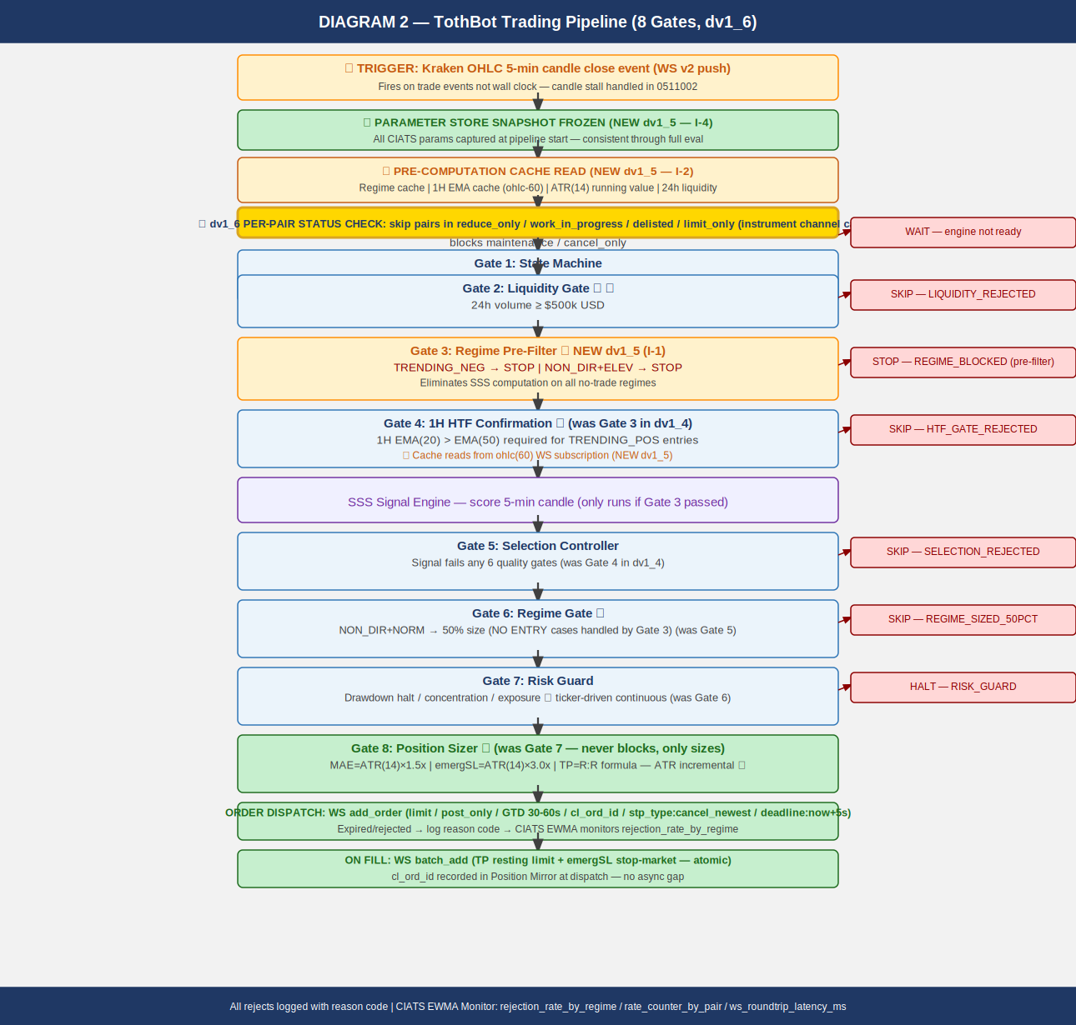
The pipeline fires on every 5-minute OHLC candle close event. Synchronous and event-driven. 8 gates. Gate 3 (Regime Pre-Filter) new in dv1_5. Per-pair status check new in dv1_6.
NOTE — OHLC fires on trade events, not wall clock. If no trades occur after an interval border, no message sent until next trade. Liquidity Gate ($500k/day) reduces this risk. Same stall behavior applies to ohlc(60). TothBot must handle stalled system clock.

3.1 Gate Summary
PRE-STEP: Parameter Store Snapshot Frozen (NEW dv1_5 — I-4). CIATS params captured as read-only snapshot. CIATS writes applied only at inter-trade boundaries.
PRE-STEP: Pre-Computation Cache Read (NEW dv1_5 — I-2). Hot path reads: regime | 1H EMA | ATR(14) | 24h liquidity | per-pair status. Zero computation on hot path.
★ dv1_6: Per-pair Instrument Status Check. Skip pairs in: reduce_only, work_in_progress, delisted, limit_only, cancel_only, maintenance ★ dv1_13 AR-039. Only online or post_only pairs proceed.
Gate 1: State Machine — Kraken engine = maintenance or cancel_only: WAIT
Gate 2: Liquidity Gate ★ — 24h volume < $500k USD: SKIP → LIQUIDITY_REJECTED
Gate 3: Regime Pre-Filter ★ NEW dv1_5 — TRENDING_NEG (any vol) or NON_DIR+ELEVATED: STOP → REGIME_BLOCKED
Gate 4: 1H HTF Confirmation ★ — 1H EMA(20) ≤ EMA(50) for TRENDING_POS entries: SKIP → HTF_GATE_REJECTED
SSS: Signal Engine — scores 5-min candle. Only reached if Gate 3 passed.
Gate 5: Selection Controller — signal fails any of 6 quality gates: SKIP → SELECTION_REJECTED
Gate 6: Regime Gate ★ — NON_DIR+NORMAL: 50% position size. All NO ENTRY cases blocked by Gate 3.
Gate 7: Risk Guard — drawdown halt / concentration / exposure / USD availability (AR-052, AR-053 dv1_13). Pass or HALT. ★ Ticker-driven continuous drawdown monitoring (I-7 dv1_5).
Gate 8: Position Sizer ★ — MAE=ATR×1.5x (AR-047 dv1_13: Decimal.quantize()), emergSL=ATR×3.0x, TP=R:R formula. Never blocks — only sizes.
EVIDENCE BASE: 15-20% higher win rates with daily+hourly confirmation (5 independent sources 2024-2025). Market Cipher: accuracy drops 65% in TRENDING to 45-50% in NON_DIRECTIONAL. Break-even 40% for 1:1.5 R:R.

4. Exit Architecture — Ground Zero Redesign for Kraken
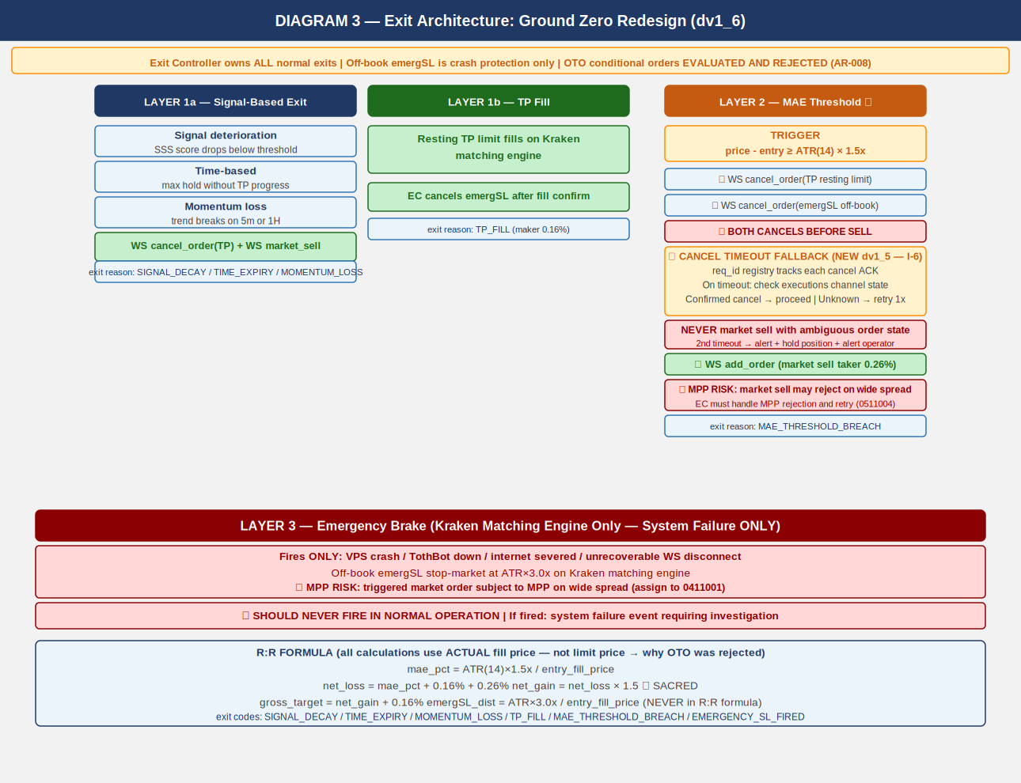
Rebuilt from zero for Kraken. Exit Controller owns all normal exits. Kraken off-book emergency SL stop order is crash protection only. OTO evaluated and rejected (AR-008).

4.1 Three-Layer Summary
Layer 1a — Signal-Based Exit: Signal decay / time expiry / momentum loss. WS cancel TP + market sell.
Layer 1b — TP Fill: Resting TP limit on Kraken matching engine fills. EC cancels emergSL after fill confirm.
Layer 2 ★ — MAE Threshold: bid_price - entry ≥ ATR(14) × 1.5x. SEQUENCE CRITICAL: (1) cancel TP (2) cancel emergSL THEN (3) market sell. Cancel timeout fallback (I-6): req_id registry tracks ACK. Ambiguous state: HOLD position, alert operator. NEVER market sell with ambiguous order state.
Layer 3 ★ — Emergency Brake: VPS/TothBot/internet failure ONLY. Off-book emergSL stop order at ATR(14)×3.0x. NEVER in normal operation. triggers.reference="last" MANDATORY (AR-046 dv1_13). MPP risk: triggered market order subject to MPP.

4.2 R:R Formula
mae_pct = ATR(14) × 1.5x / entry_FILL_price (uses ACTUAL fill price, not limit)
net_loss = mae_pct + 0.16% + 0.26% (entry maker + MAE taker exit)
net_gain = net_loss × 1.5 *** SACRED — HARDCODED ***
gross_target = net_gain + 0.16% (TP maker exit)
emergSL_dist = ATR(14) × 3.0x / entry_FILL_price (NEVER in R:R formula)

NOTE: All calculations use actual fill price, not limit price.
OTO uses limit price — this is why OTO was rejected (AR-008).

★ AR-047 dv1_13: ALL price/qty rounding via Decimal.quantize() — NEVER math.floor/ceil.
entry_price: ROUND_DOWN | order_qty: ROUND_DOWN
tp_price: ROUND_UP | emergSL trigger: ROUND_DOWN
All Kraken API values: Decimal(str(value)) immediately on receipt.

5. Regime Taxonomy
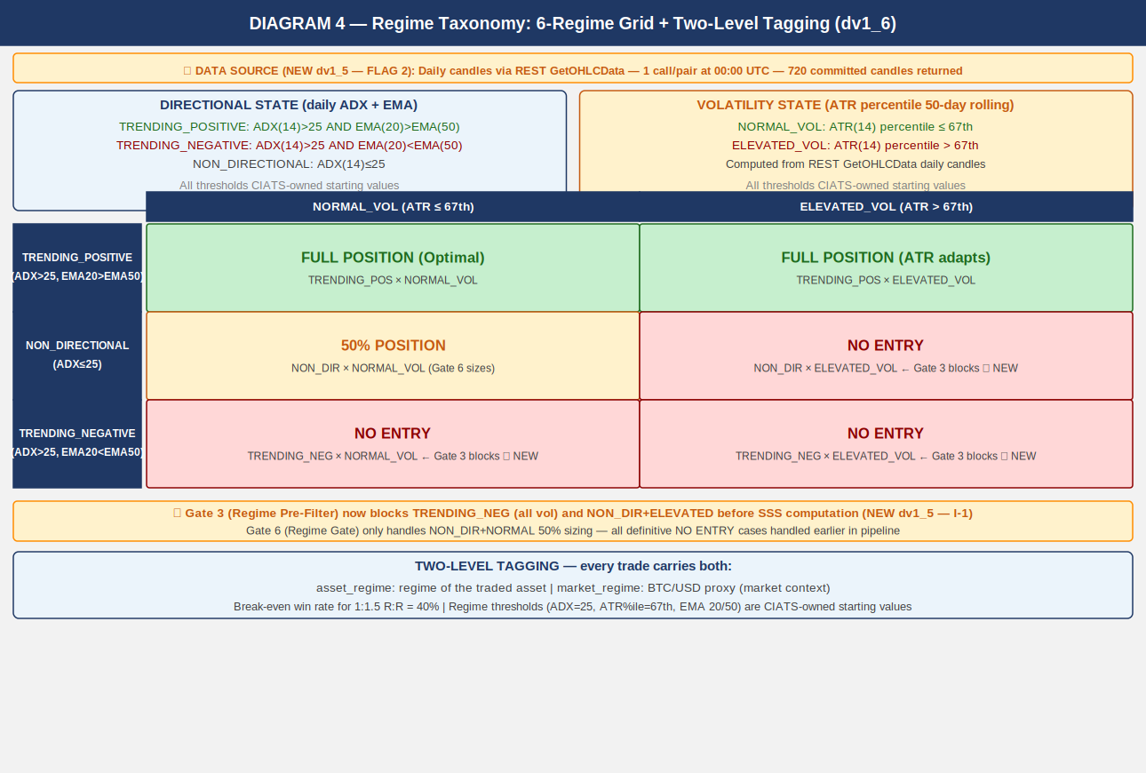
Six-regime grid is foundation of CIATS regime-segmented analysis. Every trade tagged with both asset_regime and market_regime (BTC proxy). Computed daily at 00:00 UTC.

5.1 Computation
DATA SOURCE: Daily candles via REST GetOHLCData(interval=1440). 720 entries returned.
STARTUP: Also runs at startup (AR-049 dv1_13) for immediate regime classification.
asyncio.gather() across pairs. 1.1s stagger within same pair (AR-036).

CRITICAL (GAP-03 dv1_6): response[-1] is ALWAYS the current uncommitted candle.
MUST be excluded from ALL calculations (ADX, EMA, ATR). Use only response[:-1].

Directional state: ADX(14) + EMA(20) vs EMA(50) on DAILY candles (response[:-1] ONLY)
Volatility state: ATR(14) percentile rank in 50-day rolling window

TRENDING_POSITIVE: ADX(14) > 25 AND EMA(20) > EMA(50)
TRENDING_NEGATIVE: ADX(14) > 25 AND EMA(20) < EMA(50)
NON_DIRECTIONAL: ADX(14) ≤ 25
NORMAL_VOL: ATR percentile ≤ 67th
ELEVATED_VOL: ATR percentile > 67th

asset_regime + market_regime (BTC/USD proxy) both tagged on every trade.
ADX convergence: 128 candles needed. 719 available. Factor of safety: 5.6x.

ALL REGIME THRESHOLDS ARE CIATS-OWNED STARTING VALUES.
CIATS validates each after 600 closed trades (100+ per regime bucket).

6. CIATS Architecture and Data Flows
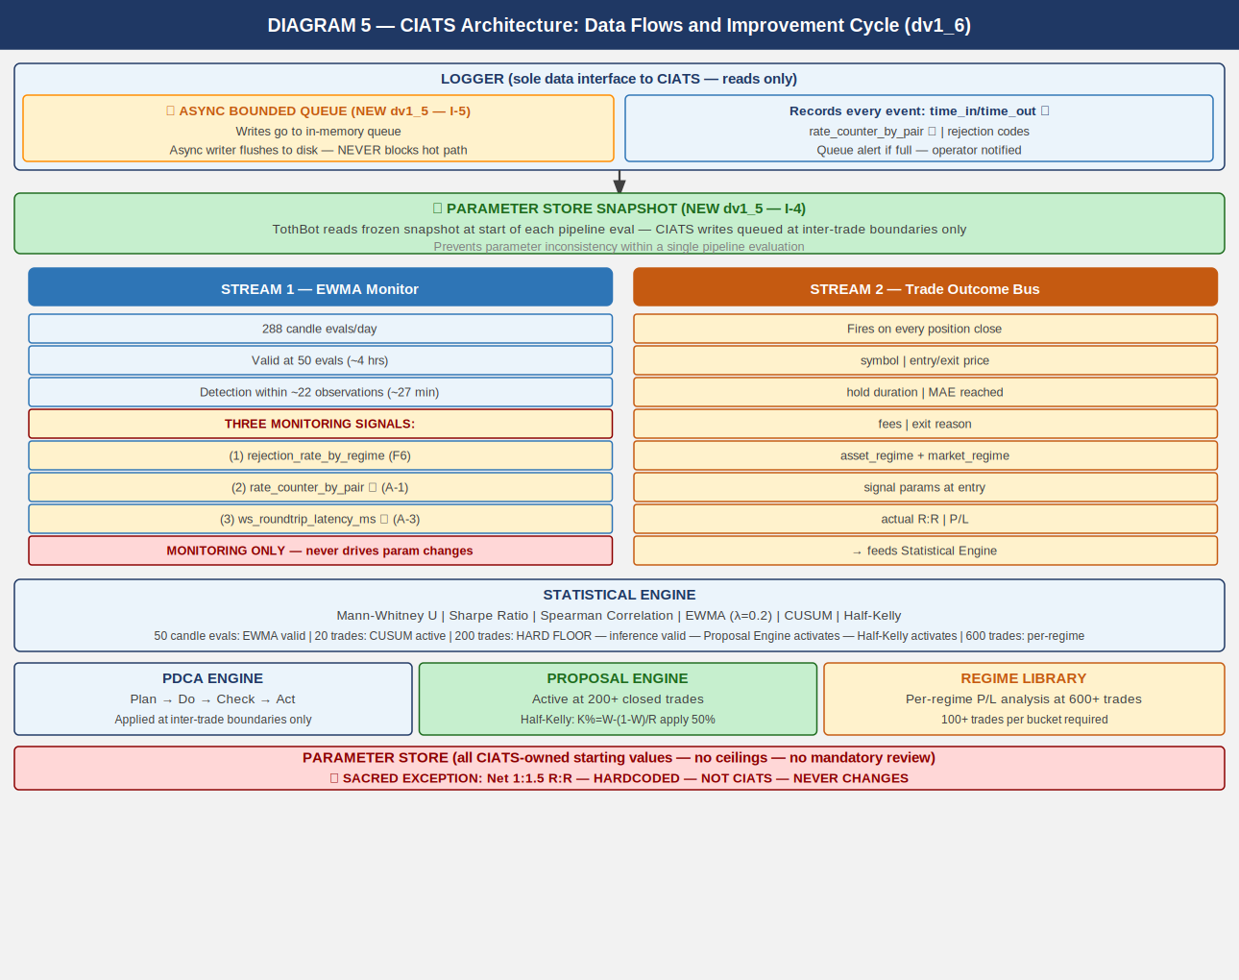
CIATS is fully asynchronous. Never blocks the trading critical path. Reads ONLY from the Logger. Writes ONLY to the Parameter Store. Deming PDCA governs every change.

6.1 Two Data Streams
Stream 1: EWMA Monitor
288 candle evals/day. Valid at 50 evals (~4 hrs). lambda=0.2 [half-life=3.1 evals]. MONITORING SIGNALS ONLY — never drives parameter changes.
(1) rejection_rate_by_regime (F6)
(2) rate_counter_by_pair from executions channel (A-1)
(3) ws_roundtrip_latency_ms from WS response timestamps (A-3)
Stream 2: Trade Outcome Bus
Fires on each position close. Captures: symbol, entry/exit price, hold duration, MAE reached, fees, exit reason, both regime tags, signal params at entry, actual R:R, P/L.
Logger — Async Bounded Queue (NEW dv1_5 — I-5)
Writes go to in-memory bounded queue (10,000 entries). Separate async writer flushes to disk. Logger NEVER blocks the trading hot path. Queue must be bounded with immediate alert if queue fills.
Parameter Store — Snapshot Pattern (NEW dv1_5 — I-4)
TothBot takes frozen snapshot at start of each pipeline eval. Pipeline uses snapshot throughout. CIATS writes queued and applied only at confirmed inter-trade boundaries.

6.2 Statistical Thresholds
50 candle evals: EWMA Monitor valid. Monitoring only. lambda=0.2 validated.
200 trades HARD FLOOR: Inference valid. Proposal Engine activates. Half-Kelly activates.
SE(win_rate)~3.5%, SE(Sharpe)~7.2% [FP/DP validated dv1_6].
600 trades: Per-regime analysis. 100+ per bucket. MW power ~85% at alpha=0.01.
Rolling 200-300: Current performance window.
Full corpus: Zero-cost historical library.

Mann-Whitney alpha: alpha=0.01 (one-sided). 99% confidence required.
Spearman rho: |rho| > 0.3 AND p < 0.05 (both conditions required).
CUSUM parameters: k=0.5*sigma, h=4*sigma. Starting values.
PDCA minimum interval: Min 50 trades between any two parameter changes.

7. Complete System: One CIATS-Owned Organism
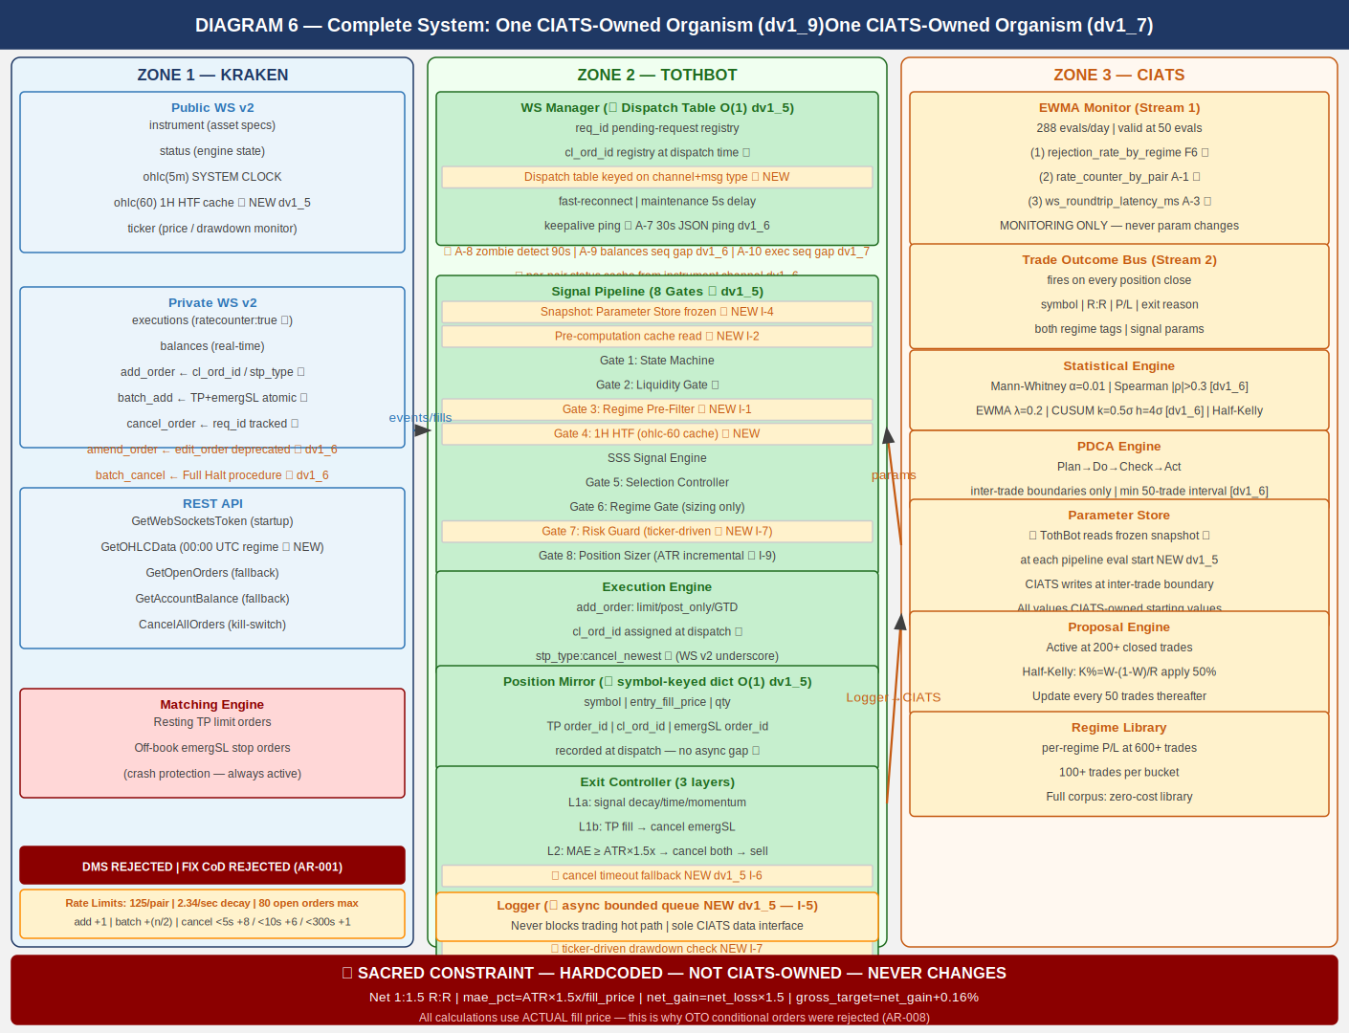
CIATS OWNS EVERYTHING EXCEPT 1:1.5 R:R: All parameters, thresholds, sizing decisions, halt thresholds, multipliers, and trading rules are CIATS-owned starting values.

8. Locked Architectural Decisions
AR-001: No Dead Man Switch — crash protection is resting TP + emergSL on matching engine. DMS and FIX cancel-on-disconnect REJECTED (destroy crash protection).
AR-002: Position Mirror — symbol-keyed dict, O(1) lookup. (NEW dv1_5 — I-3)
AR-003: Restart reconciliation — PREFERRED: snap_orders:true. FALLBACK: REST.
AR-004: Two API key pairs — DATA + TRADE. Nonce window 10,000ms.
AR-005: WS v2 only. All future Kraken enhancements in v2 only.
AR-006: Entry order — limit/post_only/GTD/cl_ord_id/stp_type:cancel_newest/deadline:now+5s. WS v2 underscore (cancel_newest). REST hyphen (cancel-newest).
AR-007: TP placement — resting limit via batch_add on fill. Actual fill price for R:R. batch_add includes deadline:now+5s and stp_type:cancel_newest.
AR-008: Emergency SL — stop-market via batch_add atomic with TP. ATR(14)×3.0x. OTO evaluated and REJECTED: uses limit price, violates R:R, Position Mirror race.
AR-009: Short deferred.
AR-010: 24/7/365. CIATS adds stand-down via PDCA if data supports.
AR-011: Net 1:1.5 R:R — SACRED — HARDCODED — NOT CIATS-OWNED.
AR-012: Fee baseline — Maker 0.16% / Taker 0.26%.
AR-013: Kraken Pro Intermediate tier confirmed.
AR-014: Logger async bounded queue (10,000 entries). Never blocks hot path. (dv1_5 I-5)
AR-015: WS dispatch table O(1) routing on channel+message type. (dv1_5 I-8)
AR-016: ATR(14) incremental running calculation. O(1) per update. (dv1_5 I-9)
AR-017: Daily regime via REST GetOHLCData at 00:00 UTC. CRITICAL: exclude response[-1]. Also run at startup (AR-049 dv1_13).
AR-018 (dv1_6) ★: amend_order PRIMARY. edit_order DEPRECATED.
AR-019 (dv1_6) ★: batch_cancel for Full Halt multi-order cancellation.
AR-020 (dv1_6) ★: Per-pair instrument status cache from instrument channel.
AR-021 (dv1_7) ★: Executions channel sequence gap detection → REST GetOpenOrders reconciliation. Missed executions = Position Mirror desync = loss risk.
AR-022 (dv1_8) ★: cancel_reason field deprecated — use reason field in all executions channel parsing.
AR-023 (dv1_8) ★: Complete exec_type dispatch table required. All 10 exec_type values handled explicitly.
AR-024 (dv1_8) ★: restated exec_type = engine maintenance amend, NOT fill/cancel. Must not trigger Position Mirror update. Elevated alert if resting order.
AR-025 (dv1_8) ★: All REST calls via aiohttp. asyncio TaskManager pattern mandatory. systemd WatchdogSec=120 with 30-second asyncio ping loop.
AR-026 (dv1_9) ★: order_status:true MANDATORY in executions subscription. Without it amended and restated exec_types are silently dropped.
AR-027 (dv1_9) ★: interval_begin replaces deprecated timestamp in OHLC WS v2 channel.
AR-028 (dv1_9) ★: price_increment replaces deprecated tick_size. qty_min and cost_min validated in Gate 8 before every add_order.
AR-029 (dv1_9) ★: WS connect max_size=10MB + open_timeout=10 on all connections.
AR-030 (dv1_9) ★: maxratecount from executions subscription ACK is the operative rate counter ceiling.
AR-031 (dv1_9) ★: Subscription ACK warnings[] parsed and logged on every subscribe call.
AR-032 (dv1_10) ★: stp_type FORMAT CORRECTION — WS v2 uses underscores: cancel_newest. REST uses hyphens: cancel-newest.
AR-033 (dv1_10) ★: deadline parameter on all WS v2 add_order and batch_add. Standard: UTC now + 5 seconds (ISO 8601).
AR-034 (dv1_10) ★: Ticker event_trigger:bbo for pairs WITH open positions. event_trigger:trades for pairs WITHOUT.
AR-035 (dv1_10) ★: aiohttp ClientSession: ClientTimeout(total=10, connect=5, sock_read=8) + TCPConnector(limit=10, limit_per_host=5, force_close=False).
AR-036 (dv1_10) ★: Regime Engine REST calls staggered at 1.1s intervals. 50 pairs × 1.1s = 55s. asyncio.sleep(1.1) between each pair.
AR-037 (dv1_10) ★: Both DATA and TRADE API keys MUST be IP-whitelisted to VPS IP (87.99.141.44). Update on migration.
AR-038 (dv1_12) ★: Kraken Status API check at startup. Query /scheduled-maintenances/upcoming.json. Non-blocking informational. Alert if maintenance within 2 hours.
AR-039 (dv1_12) ★: Per-pair NO-ENTRY states: reduce_only, work_in_progress, delisted, limit_only, cancel_only, maintenance.
AR-040 (dv1_12) ★: Exit Controller pair status adaptation: limit_only → IOC limit at best_bid. cancel_only → HOLD + CRITICAL alert. maintenance → HOLD + CRITICAL alert.
AR-041 (dv1_12) ★: cancel_order vs batch_cancel distinction: cancel_order = individual ACKs (MAE exit). batch_cancel = count response + rate bypass (Full Halt).
AR-042 (dv1_12) ★: Zombie detection heartbeat exclusion. Heartbeats MUST NOT reset last_real_data_time. Only real channel events reset.
AR-043 (dv1_12) ★: max_concurrent enforced by asyncio.BoundedSemaphore. Gate 7 checks semaphore.locked(). Execution Engine acquires before dispatch.
AR-044 (dv1_13) ★: Startup warm-up: REST GetOHLCData(interval=5) → ATR(14) seed. GetOHLCData(interval=60) → EMA(20/50) seed. GetOHLCData(interval=1440) → Regime. asyncio.gather() across pairs. 1.1s stagger within same pair. Pair state: WARM_UP until all seeded → READY.
AR-045 (dv1_13) ★: OHLC candle-close detection via interval_begin change (not wall clock). Track last_interval_begin per symbol. Fire pipeline only on change.
AR-046 (dv1_13) ★: emergSL triggers.reference="last" MUST be explicit in all batch_add calls. Never rely on defaults for crash protection parameters. Never use "index".
AR-047 (dv1_13) ★: ALL rounding via Decimal.quantize() — NEVER math.floor/ceil. All Kraken API values: Decimal(str()) immediately on receipt. Never Decimal(float). Four rounding ops: qty ROUND_DOWN, entry ROUND_DOWN, TP ROUND_UP, emergSL ROUND_DOWN.
AR-048 (dv1_13) ★: Exit Controller MAE uses bid price (not last) for long positions. bid = realizable exit. Drawdown formula also uses bid.
AR-049 (dv1_13) ★: Formal 10-step startup sequence. No pipeline until at least one READY pair. Full spec in 1011014 Startup_Sequence_Coding_Spec.
AR-050 (dv1_13) ★: Balances channel: use wallets[type=spot][id=main].balance ONLY. Top-level balance includes earn/staking wallet — not tradeable.
AR-051 (dv1_13) ★: Portfolio for SIZING = spot_usd_balance (cash only, no MTM). tradeable_USD = portfolio_USD × tradeable_pct. per_trade_USD = tradeable_USD × per_trade_pct.
AR-052 (dv1_13) ★: Drawdown baseline = spot_usd_balance at startup. Set ONCE. NEVER reset on reconnect. Current portfolio (drawdown) = cash + bid×qty of open positions. Pause at 5%, halt at 10%.
AR-053 (dv1_13) ★: Pending Order Registry: self-tracks USD committed to outstanding entry orders. Gate 7 checks available_USD = balance − pending commitments.
AR-054 (dv1_13) ★: Entry order partial fill + expiry/cancel creates unprotected position. exec_type=expired or canceled with cum_qty>0: recalculate TP/emergSL from avg_price, dispatch batch_add, enter Position Mirror. If below qty_min/cost_min: market sell immediately.
AR-055 (dv1_13) ★: Dead Man's Switch (cancel_all_orders_after) EXPLICITLY PROHIBITED. Cancels emergSL orders. Hard rule. Code review must reject any PR containing this call.
AR-056 (dv1_13) ★: Mid-session WS reconnect sequence (11 steps) distinct from startup. NEVER reset portfolio_baseline_USD or drawdown. Reconcile Position Mirror vs snap_orders. Detect positions closed during gap. Fire CIATS Trade Outcome Bus. Full spec in 1011014 Section 2.

9. Complete CIATS Parameter Registry
ALL PARAMETERS ARE CIATS-OWNED STARTING VALUES.
tradeable_pct: 50% of portfolio
per_trade_pct: 5% → Half-Kelly at 200 trades (update every 50 thereafter)
★ Applied_pct = min(raw_kelly_half, tradeable_pct/max_concurrent)
Prevents capital overcommitment across concurrent positions.
See 1011010 CIATS-KE-002 through CIATS-KE-005.
max_concurrent: 20 positions
mae_mult (ATR x): 1.5x ATR(14)
emergency_sl_mult: 3.0x ATR(14)
entry_timeout_sec: 30-60s GTD
full_halt_drawdown: 10% of portfolio ★ AR-052 dv1_13
session_pause_drawdown: 5% of portfolio ★ AR-052 dv1_13
signal_thresholds: SSS gates (derived)
adx_threshold: 25
atr_percentile_threshold: 67th
htf_ema_periods: 20/50 daily
min_volume_usd_daily: $500k USD
1:1.5 R:R net: HARDCODED — SACRED — NOT CIATS-OWNED

10. Six FP/DP Validated System Improvements
Derived from 80+ sources across 3 independent research passes plus 2 deep validation sessions (144+ sources) plus 10-search FP/DP Kraken validation sessions (TB00006–TB00017, 430+ total unique sources). 5+ sources per parameter.

Finding 1: 1H HTF Confirmation Gate [TothBot]
Gap: No layer between daily regime and 5-min entry. Evidence: 15-20% higher win rates with daily+hourly filter (5 sources 2024-2025). Change: 1H EMA(20) > EMA(50) required for TRENDING_POSITIVE. Cache from ohlc(60). Effect: Removes false signals during 1H pullbacks.

Finding 2: ATR Dynamic Stop Distances [TothBot/Exit]
Gap: Fixed 2% stop ignores real-time market volatility. Evidence: +15% performance, -22% max drawdown vs fixed stops (LuxAlgo + 4 sources). Change: MAE ATR(14)×1.5x. Emergency SL ATR(14)×3.0x. Incremental (I-9). Effect: Stop adapts to conditions. R:R formula preserved.

Finding 3: Regime Gate [TothBot]
Gap: Long momentum system trading in absent-edge conditions. Evidence: Accuracy 65%→45-50% in NON_DIRECTIONAL (Market Cipher). Break-even 40%. Change: NON_DIR+ELEV and TRENDING_NEG: no entry (Gate 3). NON_DIR+NORM: 50% (Gate 6). Effect: Stops trading when documented edge is absent.

Finding 4: Minimum Liquidity Gate [TothBot]
Gap: No minimum 24h volume on asset selection. Evidence: $1M+/day minimum for clean execution (Coin Bureau + 4 sources). Change: min_24h_volume_usd $500k starting. Effect: Protects fee formula. Ensures clean post_only fills and SL execution.

Finding 5: CIATS Half-Kelly Pathway [CIATS]
Gap: Fixed 5% sizing had no defined data-driven transition. Evidence: Half-Kelly: 75% optimal growth at 50% less drawdown (MacLean-Thorp-Ziemba + 4). Change: At 200 trades: K%=W-(1-W)/R, apply 50%. Update every 50 trades. Effect: Data-driven sizing replaces arbitrary fixed fraction.

Finding 6: post_only Rejection Monitoring [CIATS]
Gap: Rejection events logged but unused by CIATS EWMA. Evidence: Rejection rate = direct signal of entry placement quality (Cube Exchange + 4). Change: CIATS EWMA adds rejection_rate_by_regime stream. Effect: Free diagnostic signal. Entry optimization pathway activated.

11. Complete Trade Lifecycle — Narrative Reference

11.1 Normal Trade (Entry to TP or Exit Controller)
OHLC 5-min candle close fires on public WS v2 (interval_begin change detected ★ AR-045)
Parameter Store snapshot frozen — all CIATS params captured (NEW dv1_5 — I-4)
Pre-computation cache read — regime, 1H EMA, ATR(14) incremental, 24h liquidity (I-2)
★ Per-pair instrument status check — skip reduce_only/work_in_progress/delisted/
limit_only/cancel_only/maintenance [dv1_13 AR-039]
Gate 1: State Machine — online or post_only: continue; else halt and wait
Gate 2: Liquidity Gate — 24h volume >= $500k: continue; else skip
Gate 3: Regime Pre-Filter — TRENDING_NEG or NON_DIR+ELEV: STOP; else continue (I-1)
Gate 4: 1H HTF Gate — 1H EMA(20) > EMA(50) for TRENDING_POS: continue; else skip
Signal Engine: SSS score computed on 5-min candle
Gate 5: Selection Controller — 6-gate quality evaluation: pass or reject
Gate 6: Regime Gate — TRENDING_POS: proceed; NON_DIR+NORM: 50% size
Gate 7: Risk Guard — drawdown / concentration / exposure / USD availability ★ AR-052/053
available_USD = spot_usd_balance - pending_orders commitments ★ AR-053
Gate 8: Position Sizer — MAE=ATR×1.5x, emergSL=ATR×3.0x, TP=R:R formula
ALL rounding: Decimal.quantize() ★ AR-047
Execution: WS add_order (limit/post_only/GTD 30-60s/cl_ord_id/stp_type:cancel_newest/deadline:now+5s)
If expired (cum_qty==0) or rejected: log reason → CIATS EWMA monitors rejection rate. Done.
★ If expired/canceled with cum_qty > 0: PARTIAL FILL — dispatch TP/emergSL from avg_price (AR-054)
If filled (full): WS batch_add → TP (resting limit) + emergSL (stop-market) ATOMIC.
batch_add: cl_ord_id/stp_type:cancel_newest/deadline:now+5s
emergSL: triggers.reference="last" MANDATORY ★ AR-046
ALL prices pre-rounded via Decimal.quantize() before dispatch ★ AR-047
Position Mirror records: symbol (key), entry_fill_price, qty, TP id, cl_ord_id, emergSL id
Balances: use wallets[spot/main].balance ONLY ★ AR-050
portfolio_baseline_USD set once at startup. NEVER reset. ★ AR-052
Exit Controller monitors via ticker:bbo (continuous bid-price drawdown check — I-7)
Logger records full entry via async queue. CIATS Trade Outcome Bus ready.
TP fills: EC cancels emergSL. Or EC fires Layer 1/2 exit.
Logger records full exit. CIATS Trade Outcome Bus fires with complete trade record.

11.2 Layer 2 MAE Exit (Adverse Price)
Exit Controller detects: entry_fill_price - bid_price >= ATR(14) × 1.5x ★ AR-048
WS cancel_order: cancel TP resting order (individual ACK tracking — AR-041)
WS cancel_order: cancel emergSL stop order (SEQUENCE CRITICAL: both cancels BEFORE sell)

CANCEL TIMEOUT FALLBACK (NEW dv1_5 — I-6):
req_id registry tracks each cancel ACK. On timeout: check executions channel state.
Confirmed cancelled: proceed. State unknown: retry once. Second timeout: ALERT +
hold position. NEVER issue market sell with ambiguous order state.

WS add_order: market sell (taker 0.26%)
MPP NOTE: Market sell subject to MPP. EC MUST handle rejection and retry.
Logger: exit reason = MAE_THRESHOLD_BREACH
CIATS Trade Outcome Bus fires

11.3 Emergency SL (Layer 3 — System Failure Only)
VPS crashes / TothBot dies / internet severs / unrecoverable WS disconnect
Kraken matching engine fires off-book emergSL stop-market at ATR × 3.0x
triggers.reference="last" ensures trigger fires even if index feed is unavailable ★ AR-046
MPP NOTE: Triggered market order subject to MPP.
On restart: reconciliation detects closed position → Logger: EMERGENCY_SL_FIRED
THIS IS A SYSTEM FAILURE EVENT. SHOULD NEVER FIRE IN NORMAL OPERATION.

12. Open Items — Require Specification Documents
OI-001: Signal generation (SSS) — FP/DP derivation required. Blocks 0811001, 0811002.
OI-002: Asset selection universe — Kraken USDT/USDC pairs.
OI-003: Exit Controller full specification — MPP handling, cancel timeout fallback, ticker-driven drawdown, batch_cancel for Full Halt.
OI-004: Entry limit placement — evaluate bbo trigger, L2 book (PL-010), L3 book wss://ws-l3.kraken.com/v2.
OI-005: Selection Controller — 6-gate spec, must include per-pair status check.
OI-006: CIATS specification — Mann-Whitney alpha=0.01, Spearman |rho|>0.3, CUSUM k/h, PDCA 50-trade interval.
OI-007: AA=04 Exchange Interface formal document.
OI-008: All AA=10 coding specs. WD documents active: 1011001 dv1_4, 1011002 dv1_9, 1011010 dv1_2, 1011011 dv1_1, 1011012 dv1_2, 1011013 dv1_2, 1011014 dv1_1, 0411001 dv1_8.

13. Revision History
dv1_0 03-23-2026 Initial document.
dv1_1 03-23-2026 Added all six system flow diagrams.
dv1_2 03-24-2026 Six changes: C-1 emergSL terminology, C-2 rate limits, C-3 OHLC stall, A-1 ratecounter, A-2 req_id, A-3 latency logging.
dv1_3 03-24-2026 Rebuilt as correct .docx with all six diagrams embedded.
dv1_4 03-24-2026 Seven changes: C-1 MPP, A-1 AR-001 expansion, A-2 cl_ord_id, A-3 snap_orders, A-4 stp_type, A-5 reconnect distinction, A-6 OTO rejected.
dv1_5 03-24-2026 Eleven changes: FLAG1 ohlc(60), FLAG2 REST GetOHLCData, I-1 Gate 3, I-2 cache, I-3 Position Mirror O(1), I-4 Parameter Store snapshot, I-5 Logger async queue, I-6 cancel timeout, I-7 ticker drawdown, I-8 WS dispatch table, I-9 ATR incremental.
dv1_6 03-24-2026 Six changes from 10-search FP/DP validation. amend_order primary, batch_cancel, L3 URL. Rate table updated. A-7 WS ping, A-8 zombie detection, A-9 balances seq gap. Per-pair instrument status check. GetOHLCData response[-1] exclusion. Auth verification, CIATS statistical thresholds.
dv1_7 03-25-2026 A-10: Executions channel sequence gap detection → REST GetOpenOrders reconciliation. AR-021. Diagrams 1 and 6 updated.
dv1_8 03-25-2026 Eight changes (TB00009 Part 2). A-11 cancel_reason deprecated. A-12 complete exec_type enum. A-13 restated exec_type. A-14 Spot REST auth unchanged (PL-014 resolved). IMP-06 aiohttp. IMP-07 asyncio TaskManager. IMP-08 systemd watchdog. AR-022–025. 1011013 new.
dv1_9 03-25-2026 Six requirements from second 10-search validation (TB00010). A-15 order_status:true CRITICAL. A-16 interval_begin. A-17 price_increment/qty_min/cost_min. A-18 max_size=10MB. A-19 maxratecount. AR-026–031. 0411001 dv1_2, 1011002 dv1_2.
dv1_10 03-25-2026 Seven findings from third validation (TB00011). A-20 stp_type FORMAT CORRECTION. A-21 deadline. A-22 aiohttp ClientTimeout+TCPConnector. A-23 Ticker bbo. A-24 Regime stagger. AR-032–037. 0411001 dv1_3, 1011002 dv1_3, 1011012 dv1_1, 1011001 dv1_1.
dv1_12 03-25-2026 Ten text-only changes from fourth (TB00012), fifth (TB00013), sixth (TB00014) validations. AR-038 Status API. AR-039 status check expanded. AR-040 Exit Controller pair status. AR-041 cancel_order/batch_cancel distinction. AR-042 zombie heartbeat exclusion. AR-043 BoundedSemaphore. 0411001 dv1_6, 1011002 dv1_6, 1011010 dv1_2, 1011011 dv1_0, 1011012 dv1_2.
dv1_13 03-26-2026 Fourteen text-only changes from seventh (TB00015), eighth (TB00016), ninth (TB00017) validations. No diagram changes. AR-044 startup warm-up via GetOHLCData (ATR, EMA, Regime). AR-045 OHLC candle-close detection via interval_begin. AR-046 emergSL triggers.reference=last explicit. AR-047 ALL rounding via Decimal.quantize() — NEVER math.floor/ceil. AR-048 MAE uses bid price for longs. AR-049 formal 10-step startup sequence (1011014). AR-050 balances spot/main wallet only. AR-051 portfolio sizing = cash only. AR-052 drawdown baseline set once at startup — NEVER reset on reconnect. AR-053 Pending Order Registry. AR-054 partial fill + expiry/cancel creates unprotected position — must protect. AR-055 Dead Man's Switch EXPLICITLY PROHIBITED. AR-056 mid-session reconnect sequence (1011014 Section 2). 1011001 dv1_4, 1011002 dv1_9, 1011011 dv1_1, 1011014 dv1_1, 0411001 dv1_8.

